Assignment – 1

SESSION 1 - Introduction to Testing & Software Engineering

Tasks
1.
Draw a simple diagram showing the main components of a food delivery app like Zomato or Swiggy (such as user, restaurant, order, delivery partner, payment) and label how they interact in the software architecture.

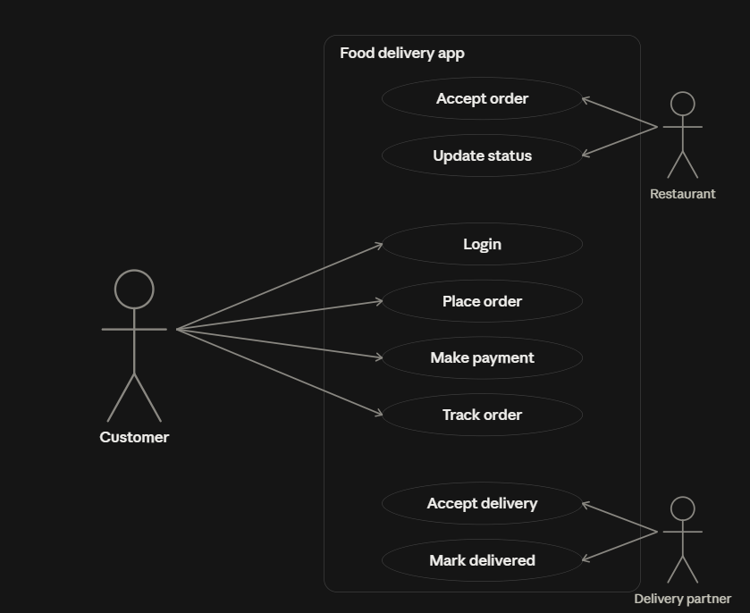

2. Pick any app you use daily (Instagram, Paytm, Flipkart, etc.) and list 5 different testing activities that must be performed before the app is released to users.<br><br><em><strong>Hint:</strong> Think about things like login, payment, notifications, speed, and security.</em>

ANSWER:-
Here we take YouTube for application. As for youtube we are going to use these 5 testing activity.

- Login and Authentication Testing (Functional)
- Payment and Subscription Testing (Transactional)
- Performance and Speed Testing (Load & Streaming)
- Push Notification Testing (System Alerts)
- Security and Privacy Testing (Security)

1 Login and Authentication Testing (Functional)

Here we verify that user is successfully login using their google account.
Test that switching account and channels is easy and effortless. After login make sure that user personalized homepage, watch history, and subscriptions load accurately.

2 Payment and Subscription Testing (Transactional)

Here we test payment process for purchasing youtube premium, channel membership, superchat. ensure that payment gateways process correctly and verify that once Premium is purchased, video ads are immediately removed across all devices

3 Performance and Speed Testing (Load & Streaming)

Here we measure video loading and buffering times across different network speeds. Test the app's ability to smoothly auto-adjust video quality based on internet strength, and ensure the "Shorts" feed scrolls without lagging or crashing.

4 Push Notification Testing (System Alerts)

Here we verify that real-time notifications are delivered promptly to the user's device. This includes testing alerts for new video uploads from subscribed channels, live stream starts, and replies to the user's comments.

5 Security and Privacy Testing (Security)

Here we ensure that videos marked as "Private" or "Unlisted" cannot be viewed by unauthorized users or found in public search results. Test privacy controls to confirm that users can successfully pause, delete, or hide their search and watch history securely.

3.Explain in your own words why testing is important at each stage of the Software Development Life Cycle (SDLC), using an example from an app like BookMyShow or IRCTC.

ANSWER:-
Testing is often thought of as something that only happens right before an app launches. in reality, finding a bug at the very end of the process is incredibly expensive and time-consuming to fix. that is why testing must be integrated into every single stage of software development life cycle. lets use bookmyshow for example.
1 requirement analysis stage
before anyone writes code, the team gathers requirements, and this stage is called "requirement testing". if a requirement is logically missing or wrong, the whole project will be built on a wrong foundation. for bookmyshow, if requirement say "allow user to book seats", we test what if two users select the same seat at the same time. if this is not thought about now, the whole booking system will be built wrong later.
2 design stage
now the team plans how the app will actually be built, and this is called "design testing". we check if the plan can actually handle real situations, before a single line of code is written. for bookmyshow, we test if the server can handle thousands of people trying to book tickets for a big movie release at the same time. if the design can't handle this, it needs to be fixed here, not after launch.
3 development stage
developers are now writing the actual code, and this is called "unit testing". small parts of the code are tested one by one, as they are written. for bookmyshow, when the developer writes the seat selection function, we test if it properly locks a seat once someone selects it, so two people cannot book the same seat by mistake.
4 testing stage
the whole app is now put together and tested as one complete system, and this is called "system testing". here we check if all the different parts work together properly. for bookmyshow, we test the full flow of selecting a movie, choosing seats, making payment, and getting the ticket, all together, and we also copy a big rush, like tickets opening for a much awaited movie.
5 maintenance stage
the app is now live and people are using it, and this is called "regression testing". even a small update can accidentally break something that was already working. for bookmyshow, if a new coupon feature is added, we test that this update did not break the existing seat booking or payment process.
So basically, testing at every stage means much fewer problems by the time real users are using the app.

4.Write down the main objectives and purpose of testing by imagining you are part of a team launching a new music streaming feature in Spotify. List at least 3 objectives and explain each in one line.

ANSWER:-

Imagine our team is launching a new music streaming feature in spotify, like live lyrics that scroll with the song. before launching, we need clear objectives for testing.

1 to check if the feature works properlyWhy this matters?
there's no point launching a feature if it doesn't do what it's supposed to do.

example:-
we check that lyrics actually sync correctly with every song, every time, not just sometimes.

2 to find and fix problems before users find them
Why this matters?
if users find bugs first, they leave bad reviews and lose trust in the app.

example:-
we check for issues like song skipping or lyrics not matching properly, and fix them before real users even see the feature.

3 to make sure the feature works smoothly for everyone
Why this matters?
not everyone has a new phone or fast internet, so feature should still work fine for them.

example:-
we check that the feature works properly even for people with a slow connection or an older phone, not just the latest ones.

